A link has a transmission speed of 10⁶ bits/sec. It uses data packets of size 1000 bytes each. Assume that the acknowledgment has negligible transmission delay, and that its propagation delay is the same as the data propagation delay. Also assume that the processing delays at nodes are negligible. The efficiency of the stop-and-wait protocol in this setup is exactly 25%. Find the one-way propagation delay (in milliseconds).
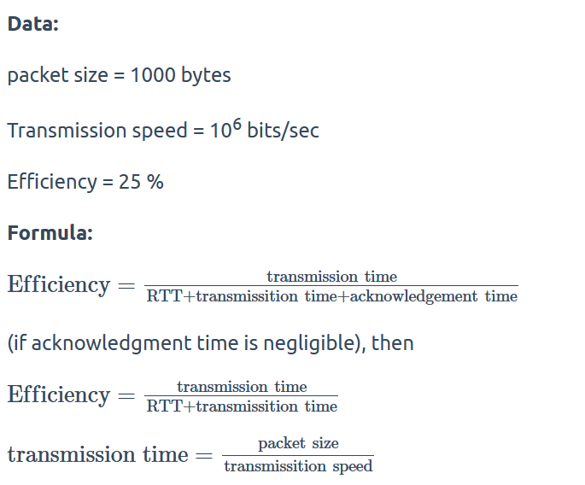
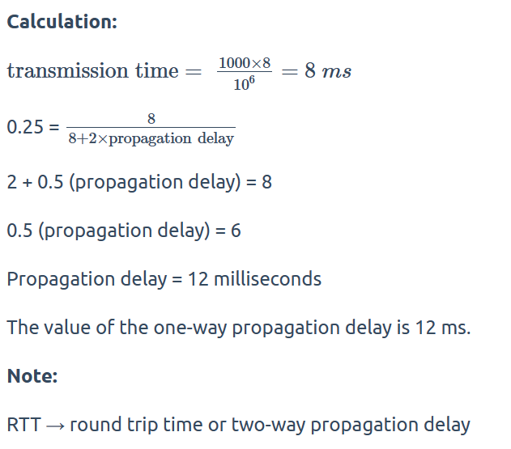

If the bandwidth of the line is 1.5 Mbps, RTT is 45 msec and packet size is 1 KB, then find the link utilization in stop and wait.

Solution-

Given-
- Bandwidth = 1.5 Mbps
- RTT = 45 msec
- Packet size = 1 KB

Calculating Transmission Delay-

Transmission delay (T_{t})
= Packet size / Bandwidth
= 1 KB / 1.5 Mbps
= (2¹⁰ x 8 bits) / (1.5 x 10⁶ bits per sec)
= 5.461 msec

Calculating Propagation Delay-

Propagation delay (T_{p})
= Round Trip Time / 2
= 45 msec / 2
= 22.5 msec

Calculating Value Of ‘a’-

a = T_{p} / T_{t}
a = 22.5 msec / 5.461 msec
a = 4.12

Calculating Link Utilization-

Link Utilization or Efficiency (η)
= 1 / 1+2a
= 1 / (1 + 2 x 4.12)
= 1 / 9.24
= 0.108
= 10.8 %

A channel has a bit rate of 4 Kbps and one way propagation delay of 20 msec. The channel uses stop and wait protocol. The transmission time of the acknowledgement frame is negligible. To get a channel efficiency of at least 50%, the minimum frame size should be ______________.

Given-
- Bandwidth = 4 Kbps
- Propagation delay (T_{p}) = 20 msec
- Efficiency >= 50%

Let the required frame size = L bits.

Calculating Transmission Delay-

Transmission delay (T_{t})
= Packet size / Bandwidth
= L bits / 4 Kbps

Calculating Value Of ‘a’-

a = T_{p} / T_{t}
a = 20 msec / ( L bits / 4 Kbps)
a = (20 msec x 4 Kbps) / L bits

Condition For Efficiency To Be At least 50%-

For efficiency to be at least 50%, we must have-
1 / 1+2a >= 1/2
a <= 1/2

Substituting the value of ‘a’, we get-
(20 msec x 4 Kbps) / L bits <= 1/2
L bits >= (20 msec x 4 Kbps) x 2
L bits >= (20 x 10⁻³ sec x 4 x 10³ bits per sec) x 2
L bits >= 20 x 4 bits x 2
L >= 160

From here, frame size must be at least 160 bits.

Problem-04:

If the packet size is 1 KB and propagation time is 15 msec, the channel capacity is 10⁹ b/sec, then find the transmission time and utilization of sender in stop and wait protocol.

Solution-

Given-
- Packet size = 1 KB
- Propagation time (T_{p}) = 15 msec
- Channel capacity = Bandwidth (here) = 10⁹ b/sec

NOTE-

- Generally, channel capacity is the total number of bits which a channel can hold. So, its unit is bits.
- But here, channel capacity is actually given as bandwidth because its unit is b/sec.

Calculating Transmission Delay-

Transmission delay (T_{t})
= Packet size / Bandwidth
= 1 KB / 10⁹ bits per sec
= 2¹⁰ bits / 10⁹ bits per sec
= 1.024 μsec

Calculating Value Of ‘a’-

a = T_{p} / T_{t}
a = 15 msec / 1.024 μsec
a = 15000 μsec / 1.024 μsec
a = 14648.46

Calculating Sender Utilization-

Sender Utilization or Efficiency (η)
= 1 / 1+2a
= 1 / (1 + 2 x 1468.46)
= 1 / 29297.92
= 0.0000341
= 0.00341 %

Problem-05:

Consider a MAN with average source and destination 20 Km apart and one way delay of 100 μsec. At what data rate does the round trip delay equals the transmission delay for a 1 KB packet?

Solution-

Given-
- Distance = 20 Km
- Propagation delay (T_{p}) = 100 μsec
- Packet size = 1 KB

We need to have-
Round Trip Time = Transmission delay
2 x Propagation delay = Transmission delay

Substituting the values in the above relation, we get-
2 x 100 μsec = 1 KB / Bandwidth
Bandwidth = 1 KB / 200 μsec
Bandwidth = (2¹⁰ x 10⁶ / 200 ) bytes per sec
Bandwidth = 5.12 MBps or 40.96 Mbps

Problem-07:

The values of parameters for the stop and wait ARQ protocol are as given below-
- Bit rate of the transmission channel = 1 Mbps
- Propagation delay from sender to receiver = 0.75 ms
- Time to process a frame = 0.25 ms
- Number of bytes in the information frame = 1980
- Number of bytes in the acknowledge frame = 20
- Number of overhead bytes in the information frame = 20
Assume that there are no transmission errors. Then the transmission efficiency (in %) of the stop and wait ARQ protocol for the above parameters is ___________ . (correct to 2 decimal places)

Solution-

Given-
- Bandwidth = 1 Mbps
- Propagation delay (T_{p}) = 0.75 ms
- Processing time (T_{process}) = 0.25 ms
- Data frame size = 1980 bytes
- Acknowledgement frame size = 20 bytes
- Overhead in data frame = 20 bytes

Calculating Useful Time-

Useful data sent
= Transmission delay of useful data bytes sent
= Useful data bytes sent / Bandwidth
= (1980 bytes – 20 bytes) / 1 Mbps
= 1960 bytes / 1 Mbps
= (1960 x 8 bits) / (10⁶ bits per sec)
= 15680 μsec
= 15.680 msec

Calculating Total Time-

Total time
= Transmission delay of data frame + Propagation delay of data frame + Processing delay of data frame + Transmission delay of acknowledgement + Propagation delay of acknowledgement
= (1980 bytes / 1 Mbps) + 0.75 msec + 0.25 msec + (20 bytes / 1 Mbps) + 0.75 msec
= 15.840 msec + 0.75 msec + 0.25 msec + 0.160 msec + 0.75 msec
= 17.75 msec

Calculating Efficiency-

Efficiency (η)
= Useful time / Total time
= 15.680 msec / 17.75 msec
= 0.8833
= 88.33%

Problem-08:

A sender uses the stop and wait ARQ protocol for reliable transmission of frames. Frames are of size 1000 bytes and the transmission rate at the sender is 80 Kbps. Size of an acknowledgement is 100 bytes and the transmission rate at the receiver is 8 Kbps. The one way propagation delay is 100 msec.
Assuming no frame is lost, the sender throughput is __________ bytes/sec.

Solution-

Given-
- Frame size = 1000 bytes
- Sender bandwidth = 80 Kbps
- Acknowledgement size = 100 bytes
- Receiver bandwidth = 8 Kbps
- Propagation delay (T_{p}) = 100 msec

Calculating Transmission Delay Of Data Frame-

Transmission delay (T_{t})
= Frame size / Sender bandwidth
= 1000 bytes / 80 Kbps
= (1000 x 8 bits) / (80 x 10³ bits per sec)
= 0.1 sec
= 100 msec

Calculating Transmission Delay Of Acknowledgement-

Transmission delay (T_{t})
= Acknowledgement size / Receiver bandwidth
= 100 bytes / 8 Kbps
= (100 x 8 bits) / (8 x 10³ bits per sec)
= 100 msec

Calculating Useful Time-

Useful Time
= Transmission delay of data frame
= 100 msec

Calculating Total Time-

Total Time
= Transmission delay of data frame + Propagation delay of data frame + Transmission delay of acknowledgement + Propagation delay of acknowledgement
= 100 msec + 100 msec + 100 msec + 100 msec
= 400 msec

Calculating Efficiency-

Efficiency (η)
= Useful time / Total time
= 100 msec / 400 msec
= 1 / 4
= 25%

Calculating Sender Throughput-

Sender throughput
= Efficiency (η) x Sender bandwidth
= 0.25 x 80 Kbps
= 20 Kbps
= (20 x 1000 / 8) bytes per sec
= 2500 bytes/sec

Problem-09:

Using stop and wait protocol, sender wants to transmit 10 data packets to the receiver. Out of these 10 data packets, every 4th data packet is lost. How many packets sender will have to send in total?

Solution-

Draw a time line diagram and analyze.
The packets will be sent as-
1, 2, 3, 4, 4, 5, 6, 7, 7, 8, 9, 10, 10
The lost packets are- 4, 7 and 10.
Thus, sender will have to send 13 data packets in total.

1) A system uses the Stop-and-Wait Protocol. If each packet carries 1000 bits of
data, Determine how long does it take to send 1 million bits of data if the distance between the
sender and receiver is 5000 Km and the propagation speed is 2 x 10⁸ m/s? Ignore transmission, waiting, and processing delays. We assume no data or control frame is lost or damaged.
2) . Repeat Exercise 1 using the Go-back-N ARQ Protocol with a window size of 7. Ignore the overhead due to the header and trailer.
3) Repeat Exercise 1 using the Selective-Repeat ARQ Protocol with a window size of 4. Ignore the overhead due to the header and the trailer.

Since we are asked to ignore transmission time , waiting and processing delays etc..so in overall we have to consider propagation time only
Propagation time (sender to receiver) = 5000 / 2*(10^8)
= 25 msec.
RTT = 2*25 = 50 msec
No. of packets = 10^6 / 10^3
= 1000 packets
Total time = propagation time for data + propagation time for ack
Case 1 :
In stop and wait, sender window size = 1 …now when ack of first packet will reach to sender then only sender will send next.
Hence, time for one packet = 25 + 25 = 50msec
Time for 1000 packets = 50*1000 = 50000 msec
CASE 3 : lets talk about selective repeat then we will talk about go back afterwards :
first just go through the diagram...in this four packets will go at a time..since no transmission time etc only propagation time..
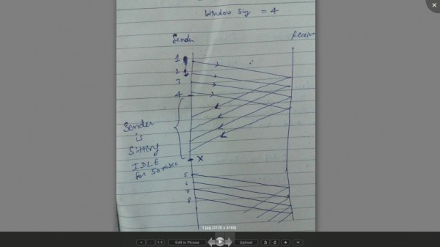
After sending 4 packets now sender will sit idle for 50 msec (i.e RTT) and then the at POINT " X " sender's window will again become ready to send 4 more packets. HENCE in group of 4 , packets will be sent same process will repeat (like sender will wait for another 50 msec.).
No. of times sender is sitting idle = 1000/4
=250
NOTE : when last 4 packets will be sent then sender will not have to wait for 50 msec because we are told no packet is lost or demaged. so sender will not wait for ack.
hence time = 249 * 50msec = 12450 msec.
CASE 2 lets talk about GO BACK N ;
HERE also NO DIFFERENCE same as previous . The only difference is for 7 packets only 1 ACK will come to sender but that also will consume same propagation time .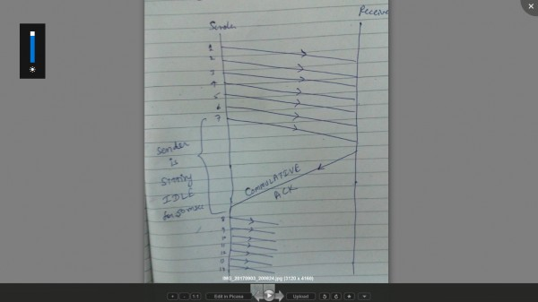
No. of times sender will sit idle = 1000/7
= 143
BUT we will take 142 times only...reason for this is the same explanation given in NOTE i have given above (in the case 3)
so, time = 142 * 50msec
= 7100 msec
FINAL ANSWERS ; case 1 - 50,000 msec
case 2 - 7100 msec
case 3 - 1240 msec

Consider a selective repeat sliding window protocol that uses a frame size of 1 KB to send data on a 1.5 Mbps link with a one-way latency of 50 msec. To achieve a link utilization of 60%, the minimum number of bits required to represent the sequence number field is ________.

Transmission delay = Frame Size/bandwidth
= (1*8*1024)/(1.5 * 10^6)=5.33ms
Propagation delay = 50ms
Efficiency = Window Size/(1+2a) = .6

a = Propagation delay/Transmission delay
So, window size = 11.856(approx)
min sequence number = 2*window size = 23.712
bits required in Min sequence number = log₂(23.712)
Answer is 4.56

Ceil(4.56) = 5

ROBLEMS BASED ON SLIDING WINDOW PROTOCOL-

Problem-01:

If transmission delay and propagation delay in a sliding window protocol are 1 msec and 49.5 msec respectively, then-
- What should be the sender window size to get the maximum efficiency?
- What is the minimum number of bits required in the sequence number field?
- If only 6 bits are reserved for sequence numbers, then what will be the efficiency?

Solution-

Given-
- Transmission delay = 1 msec
- Propagation delay = 49.5 msec

Part-01:

To get the maximum efficiency, sender window size
= 1 + 2a
= 1 + 2 x (T_{p} / T_{t})
= 1 + 2 x (49.5 msec / 1 msec)
= 1 + 2 x 49.5
= 100
Thus,
For maximum efficiency, sender window size = 100

Part-02:

Minimum number of bits required in the sequence number field
= ⌈log₂(1+2a)⌉
= ⌈log₂(100)⌉
= ⌈6.8⌉
= 7
Thus,
Minimum number of bits required in the sequence number field = 7

Part-03:

If only 6 bits are reserved in the sequence number field, then-
Maximum sequence numbers possible = 2⁶ = 64
Now,
Efficiency
= Sender window size in the protocol / Optimal sender window size
= 64 / 100
= 0.64
= 64%

Problem-02:

If transmission delay and propagation delay in a sliding window protocol are 1 msec and 99.5 msec respectively, then-
- What should be the sender window size to get the maximum efficiency?
- What is the minimum number of bits required in the sequence number field?
- If only 7 bits are reserved for sequence numbers, then what will be the efficiency?

Solution-

Given-
- Transmission delay = 1 msec
- Propagation delay = 99.5 msec

Part-01:

To get the maximum efficiency, sender window size
= 1 + 2a
= 1 + 2 x (T_{p} / T_{t})
= 1 + 2 x (99.5 msec / 1 msec)
= 1 + 2 x 99.5
= 200
Thus,
For maximum efficiency, sender window size = 200

Part-02:

Minimum number of bits required in the sequence number field
= ⌈log₂(1+2a)⌉
= ⌈log₂(200)⌉
= ⌈7.64⌉
= 8
Thus,
Minimum number of bits required in the sequence number field = 8

Part-03:

If only 6 bits are reserved in the sequence number field, then-
Maximum sequence numbers possible = 2⁷ = 128
Now,
Efficiency
= Sender window size in the protocol / Optimal sender window size
= 128 / 200
= 0.64
= 64%

Problem-01:

A 3000 km long trunk operates at 1.536 Mbps and is used to transmit 64 byte frames and uses sliding window protocol. If the propagation speed is 6 μsec / km, how many bits should the sequence number field be?

Solution-

Given-
- Distance = 3000 km
- Bandwidth = 1.536 Mbps
- Packet size = 64 bytes
- Propagation speed = 6 μsec / km

Calculating Transmission Delay-

Transmission delay (T_{t})
= Packet size / Bandwidth
= 64 bytes / 1.536 Mbps
= (64 x 8 bits) / (1.536 x 10⁶ bits per sec)
= 333.33 μsec

Calculating Propagation Delay-

For 1 km, propagation delay = 6 μsec
For 3000 km, propagation delay = 3000 x 6 μsec = 18000 μsec

Calculating Value Of ‘a’-

a = T_{p} / T_{t}
a = 18000 μsec / 333.33 μsec
a = 54

Calculating Bits Required in Sequence Number Field-

Bits required in sequence number field
= ⌈log₂(1+2a)⌉
= ⌈log₂(1 + 2 x 54)⌉
= ⌈log₂(109)⌉
= ⌈6.76⌉
= 7 bits

Thus,
- Minimum number of bits required in sequence number field = 7
- With 7 bits, number of sequence numbers possible = 128
- We use only (1+2a) = 109 sequence numbers and rest remains unused.

Problem-02:

Compute approximate optimal window size when packet size is 53 bytes, RTT is 60 msec and bottleneck bandwidth is 155 Mbps.

Solution-

Given-
- Packet size = 53 bytes
- RTT = 60 msec
- Bandwidth = 155 Mbps

Calculating Transmission Delay-

Transmission delay (T_{t})
= Packet size / Bandwidth
= 53 bytes / 155 Mbps
= (53 x 8 bits) / (155 x 10⁶ bits per sec)
= 2.735 μsec

Calculating Propagation Delay-

Propagation delay (T_{p})
= Round Trip Time / 2
= 60 msec / 2
= 30 msec

Calculating Value of ‘a’-

a = T_{p} / T_{t}
a = 30 msec / 2.735 μsec
a = 10968.921

Calculating Optimal Window Size-

Optimal window size
= 1 + 2a
= 1 + 2 x 10968.921
= 21938.84

Thus, approximate optimal window size = 21938 frames.

Problem-03:

A sliding window protocol is designed for a 1 Mbps point to point link to the moon which has a one way latency (delay) of 1.25 sec. Assuming that each frame carries 1 KB of data, what is the minimum number of bits needed for the sequence number?

Solution-

Given-
- Bandwidth = 1 Mbps
- Propagation delay (T_{p}) = 1.25 sec
- Packet size = 1 KB

Calculating Transmission Delay-

Transmission delay (T_{t})
= Packet size / Bandwidth
= 1 KB / 1 Mbps
= (2¹⁰ x 8 bits) / (10⁶ bits per sec)
= 8.192 msec

Calculating Value of ‘a’-

a = T_{p} / T_{t}
a = 1.25 sec / 8.192 msec
a = 152.59

Calculating Bits Required in Sequence Number Field-

Bits required in sequence number field
= ⌈log₂(1+2a)⌉
= ⌈log₂(1 + 2 x 152.59)⌉
= ⌈log₂(306.176)⌉
= ⌈8.25⌉
= 9 bits

Thus,
- Minimum number of bits required in sequence number field = 9
- With 9 bits, number of sequence numbers possible = 512.
- We use only (1+2a) sequence numbers and rest remains unused.

Problem-04:

Host A is sending data to host B over a full duplex link. A and B are using the sliding window protocol for flow control. The send and receive window sizes are 5 packets each. Data packets (sent only from A to B) are all 1000 bytes long and the transmission time for such a packet is 50 μs. Acknowledgement packets (sent only from B to A) are very small and require negligible transmission time. The propagation delay over the link is 200 μs. What is the maximum achievable throughput in this communication?

Solution-

Given-
- Sender window size = Receiver window size = 5
- Packet size = 1000 bytes
- Transmission delay (T_{t}) = 50 μs
- Propagation delay (T_{p}) = 200 μs

Calculating Bandwidth-

We know,
Transmission delay = Packet size / Bandwidth

So, Bandwidth
= Packet Size / Transmission delay (T_{t})
= 1000 bytes / 50 μs
= (1000 x 8 bits) / (50 x 10⁻⁶ sec)
= 160 Mbps

Calculating Value of ‘a’-

a = T_{p} / T_{t}
a = 200 μsec / 50 μsec
a = 4

Calculating Optimal Window Size-

Optimal window size
= 1 + 2a
= 1 + 2 x 4
= 9

Calculating Efficiency-

Efficiency (η)
= Sender window size / Optimal window size
= 5 / 9
= 0.5555
= 55.55%

Calculating Maximum Achievable Throughput-

Maximum achievable throughput
= Efficiency (η) x Bandwidth
= 0.5555 x 160 Mbps
= 88.88 Mbps
= 88.88 x 10⁶ bps or 11.11 x 10⁶ Bps

Problem-05:

Station A uses 32 byte packets to transmit messages to station B using a sliding window protocol. The round trip delay between A and B is 80 msec and the bottleneck bandwidth on the path between A and B is 128 Kbps. What is the optimal window size that A should use?

Solution-

Given-
- Packet size = 32 bytes
- Round Trip Time = 80 msec
- Bandwidth = 128 Kbps

Calculating Transmission Delay-

Transmission delay (T_{t})
= Packet size / Bandwidth
= 32 bytes / 128 Kbps
= (32 x 8 bits) / (128 x 10³ bits per sec)
= 2 msec

Calculating Propagation Delay-

Propagation delay (T_{p})
= Round Trip Time / 2
= 80 msec / 2
= 40 msec

Calculating Value of ‘a’-

a = T_{p} / T_{t}
a = 40 msec / 2 msec
a = 20

Calculating Optimal Window Size-

Optimal window size
= 1 + 2a
= 1 + 2 x 20
= 41

Problem-01:

A 20 Kbps satellite link has a propagation delay of 400 ms. The transmitter employs the “go back n ARQ” scheme with n set to 10.
Assuming that each frame is 100 bytes long, what is the maximum data rate possible?
- 5 Kbps
- 10 Kbps
- 15 Kbps
- 20 Kbps

Solution-

Given-
- Bandwidth = 20 Kbps
- Propagation delay (T_{p}) = 400 ms
- Frame size = 100 bytes
- Go back N is used where N = 10

Calculating Transmission Delay-

Transmission delay (T_{t})
= Frame size / Bandwidth
= 100 bytes / 20 Kbps
= (100 x 8 bits) / (20 x 10³ bits per sec)
= 0.04 sec
= 40 msec

Calculating Value Of ‘a’-

a = T_{p} / T_{t}
a = 400 msec / 40 msec
a = 10

Calculating Efficiency-

Efficiency (η)
= N / (1+2a)
= 10 / (1 + 2 x 10)
= 10 / 21
= 0.476
= 47.6 %

Calculating Maximum Data Rate Possible-

Maximum data rate possible or Throughput
= Efficiency x Bandwidth
= 0.476 x 20 Kbps
= 9.52 Kbps
≅ 10 Kbps

Problem-03:

Station A needs to send a message consisting of 9 packets to station B using a sliding window (window size 3) and go back n error control strategy. All packets are ready and immediately available for transmission.
If every 5th packet that A transmits gets lost (but no ACKs from B ever get lost), then what is the number of packets that A will transmit for sending the message to B?

Solution-

Given-
- Total number of packets to be sent = 9
- Go back N is used where N = 3
- Every 5th packet gets lost

Step-01:

Since sender window size is 3, so sender sends 3 packets (1, 2, 3)-

Total packets sent till now from sender side = 3

Step-02:

After receiving the acknowledgement for packet-1, sender slides its window and sends packet-4.

Total packets sent till now from sender side = 4

Step-03:

After receiving the acknowledgement for packet-2, sender slides its window and sends packet-5.

Total packets sent till now from sender side = 5

Step-04:

After receiving the acknowledgement for packet-3, sender slides its window and sends packet-6.

Total packets sent till now from sender side = 6

Step-05:

After receiving the acknowledgement for packet-4, sender slides its window and sends packet-7.

Total packets sent till now from sender side = 7

Step-06:

- According to question, every 5th packet gets lost.
- So, packet-5 gets lost and when time out occurs, sender retransmits packet-5.
- In Go back N, all the following packets are also discarded by the receiver.
- So, packet-6 and packet-7 are discarded by the receiver and they are also retransmitted.
- Thus, the entire window is retransmitted.

So, we have-

Total packets sent till now from sender side = 10

Now, the next 5th packet that will be lost will be packet-7. (6, 7, 5, 6, 7)

Step-07:

After receiving the acknowledgement for packet-5, sender slides its window and sends packet-8.

Total packets sent till now from sender side = 11

Step-08:

After receiving the acknowledgement for packet-6, sender slides its window and sends packet-9.

Total packets sent till now from sender side = 12

Step-09:

- According to question, every 5th packet gets lost.
- So, packet-7 gets lost and when time out occurs, sender retransmits packet-7 and the following packets.
- Thus, the entire window is retransmitted.

So, we have-

Total packets sent till now from sender side = 15

Now, the next 5th packet that will be lost will be packet-9. (8, 9, 7, 8, 9)

Step-10:

After receiving the acknowledgement for packet-7, sender slides its window.

Total packets sent till now from sender side = 15

Step-11:

After receiving the acknowledgement for packet-8, sender slides its window.

Total packets sent till now from sender side = 15

Step-12:

- According to question, every 5th packet gets lost.
- So, packet-9 gets lost and when time out occurs, sender retransmits packet-9.

So, we have-

Total packets sent till now from sender side = 16

Finally, all the 9 packets got transmitted which took total 16 number of transmissions.

Problem-04:

In Go back 4, if every 6th packet that is being transmitted is lost and if total number of packets to be sent is 10, then how many transmissions will be required?

Solution-

- Try yourself!
- We have to solve in exactly the same way as we have solved Problem-03.
- Total number of transmissions required will be 17.

Problem-05:

A 1 Mbps satellite link connects two ground stations. The altitude of the satellite is 36504 km and speed of the signal is 3 x 10⁸ m/sec. What should be the packet size for a channel utilization of 25% for a satellite link using go back 127 sliding window protocol?
- 120 bytes
- 60 bytes
- 240 bytes
- 90 bytes

Solution-

Given-
- Bandwidth = 1 Mbps
- Distance = 2 x 36504 km = 73008 km
- Propagation speed = 3 x 10⁸ m/sec
- Efficiency = 25% = 1/4
- Go back N is used where N = 127

Let the packet size be L bits.

Calculating Transmission Delay-

Transmission delay (T_{t})
= Packet size / Bandwidth
= L bits / 1 Mbps
= L μsec

Calculating Propagation Delay-

Propagation delay (T_{p})
= Distance / Speed
= (73008 x 10³ m) / (3 x 10⁸ m/sec)
= 24336 x 10⁻⁵ sec
= 243360 μsec

Calculating Value of ‘a’-

a = T_{p} / T_{t}
a = 243360 μsec / L μsec
a = 243360 / L

Calculating Packet Size-

Efficiency (η) = N / (1+2a)
Substituting the values, we get-
1/4 = 127 / (1 + 2 x 243360 / L)
1/4 = 127 x L / (L + 486720)
L + 486720 = 508 x L
507 x L = 486720
L = 960

From here, packet size = 960 bits or 120 bytes.
Thus, Correct Option is (A).

Problem-06:

Consider a network connecting two systems located 8000 km apart. The bandwidth of the network is 500 x 10⁶ bits per second. The propagation speed of the media is 4 x 10⁶ meters per second. It is needed to design a Go back N sliding window protocol for this network. The average packet size is 10⁷ bits. The network is to be used to its full capacity.
Assume that processing delays at nodes are negligible. Then, the minimum size in bits of the sequence number field has to be ______ ?

Solution-

Given-
- Distance = 8000 km
- Bandwidth = 500 x 10⁶ bps
- Propagation speed = 4 x 10⁶ m/sec
- Packet size = 10⁷ bits

Now,
- For using the network to its full capacity, Efficiency (η) = 1
- Efficiency (η) = 1 when sender window size = 1+2a

Calculating Transmission Delay-

Transmission delay (T_{t})
= Packet size / Bandwidth
= 10⁷ bits / (500 x 10⁶ bits per sec)
= 1 / 50 sec
= 0.02 sec

Calculating Propagation Delay-

Propagation delay (T_{p})
= Distance / Speed
= 8000 km / (4 x 10⁶ m/sec)
= 2 sec

Calculating Value of ‘a’-

a = T_{p} / T_{t}
a = 2 sec / 0.02 sec
a = 100

Calculating Sender Window Size-

Sender window size
= 1 + 2a
= 1 + 2 x 100
= 201

Calculating Minimum Size Of Sequence Number Field-

Minimum number of bits required in the sequence number field
= ⌈log₂(1+2a)⌉
= ⌈log₂(201)⌉
= ⌈7.65⌉
= 8
Thus, Minimum size of sequence number field = 8 bits.

In SR protocol, suppose frames through 0 to 4 have been transmitted. Now, imagine that 0 times out, 5 (a new frame) is transmitted, 1 times out, 2 times out and 6 (another new frame) is transmitted.
At this point, what will be the outstanding packets in sender’s window?

6 , 2 , 1 , 5 , 0 , 4 , 3

Consider a 128 x 10³ bits/sec satellited communication link with one way propagation delay of 150 msec. Selective Retransmission (repeat) protocol is used on this link to send data with a frame size of 1 KB. Neglect the transmission time of acknowledgement. The minimum number of bits required for the sequence number field to achieve 100% utilization is ________ .

Solution-

Given-
- Bandwidth = 128 x 10³ bits/sec
- Propagation delay (T_{p}) = 150 msec
- Frame size = 1 KB

Now,
- To achieve 100% utilization, efficiency must be 100%.
- Efficiency is 100% when sender window size is optimal i.e. 1+2a

Calculating Transmission Delay-

Transmission delay (T_{t})
= Frame size / Bandwidth
= 1 KB / (128 x 10³ bits per sec)
= (1 x 2¹⁰ x 8 bits) / (128 x 10³ bits per sec)
= 64 msec

Calculating Value of ‘a’-

a = T_{p} / T_{t}
a = 150 msec / 64 msec
a = 2.34

Calculating Optimal Sender Window Size-

Optimal sender window size
= 1 + 2a
= 1 + 2 x 2.34
= ⌈5.68⌉
= 6

Calculating Number Of Sequence Numbers Required-

In SR Protocol, sender window size and receiver window size are same.
So, sender window size = receiver window size = 6

Now,
For any sliding window protocol, minimum number of sequence numbers required
= Sender window size + Receiver window size
= 6 + 6
= 12

Calculating Bits Required in Sequence Number Field-

To have 12 sequence numbers,
Minimum number of bits required in sequence number field
= ⌈log₂(12)⌉
= 4

Thus,
- Minimum number of bits required in sequence number field = 4
- With 4 bits, number of sequence numbers possible = 16
- We use only 12 sequence numbers and rest 4 remains unused.

assume we need to design a GBN sliding-window protocol for a network in which the bandwidth is 100Mbps and the average distance between the sender and receiver is 10,000km.Assume the average packet size is 100,000 bits and propagation speed is 2*10^8m.find the max size of the send and receive windows,the number of bits in the sequence number field and an appropriate time-out value for the timer?

